Prologis to Develop Third Build-to-Suit Facility at Wroclaw V
Prologis, Inc., the leading global owner, operator and developer of industrial real estate, today announced that in the first quarter of 2013, it signed an agreement to develop an 18,300 square metre Build-to-Suit (BTS) facility for Tradis, part of the Eurocash Group, at Prologis Park Wroclaw V. It is the third BTS facility to be developed at the park in less than 24 months.

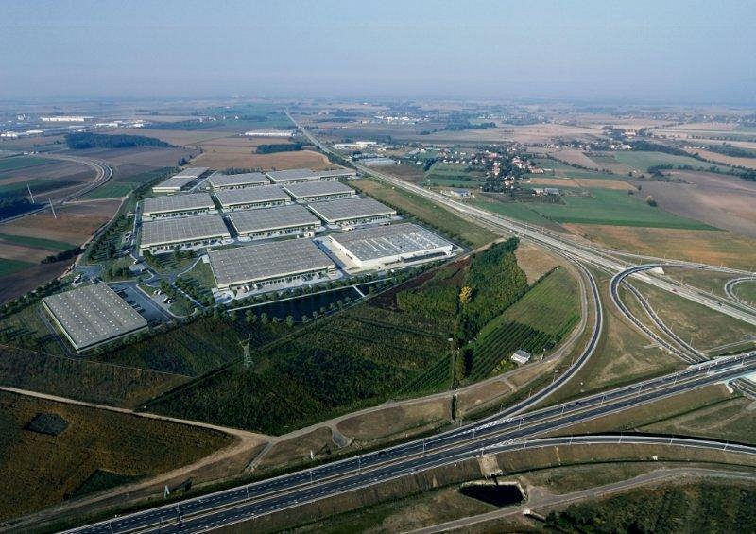
Ewa Zawadzka, business development director, Prologis Poland, said: “We are delighted that Tradis has chosen to partner with Prologis to develop its new facility. They are a very important customer and we look forward to strengthening our relationship.

“As the third BTS in less than two years, the transaction further highlights the strategic importance of Prologis Park Wroclaw V as a key logistics location, while sending a positive signal to the wider Polish market.”

In the first quarter of 2012, Prologis delivered a 19,100 square metre BTS facility to UPM Raflatac, a leading provider of self-adhesive label materials. More recently in the fourth quarter of 2012, it signed an agreement to construct a 17,800 sqm BTS facility for a leading wholesale and retail supplier of white goods and electronic equipment.
Set on 70 hectares of land, Prologis Park Wroclaw V offers significant development opportunity, with total potential distribution space of up to 290,000 square metres. The park is adjacent to Wroclaw’s future ring road, three kilometres southwest of the Wrocław Bielany junction where the A4 expressway—which runs between Berlin and Ukraine—and route E261 intersect.
With four distribution parks and 17 buildings totalling 360,000 square metres, Prologis is the largest provider of industrial real estate in the Wrocław region.
About The Eurocash Group
The Eurocash Group is one of the largest groups in Poland distributing food products, household chemicals, alcohol, and tobacco products. Through a range of distribution formats, the Eurocash Group focuses its business activities on the wholesale distribution of products to customers across all significant traditional wholesale market segments, in particular, to traditional retail stores throughout Poland and to the market segment of petrol stations, restaurants, and hotels.
About Prologis
Prologis, Inc. is the leading owner, operator and developer of industrial real estate, focused on global and regional markets across the Americas, Europe and Asia. As of Dec. 31, 2012, Prologis owned or had investments in, on a consolidated basis or through unconsolidated joint ventures, properties and development projects expected to total approximately 554 million square feet (51.5 million square meters) in 21 countries. The company leases modern distribution facilities to more than 4,500 customers, including manufacturers, retailers, transportation companies, third-party logistics providers and other enterprises.
The statements in this release that are not historical facts are forward-looking statements within the meaning of Section 27A of the Securities Act of 1933, as amended, and Section 21E of the Securities Exchange Act of 1934, as amended. These forward-looking statements are based on current expectations, estimates and projections about the industry and markets in which Prologis operates, management’s beliefs and assumptions made by management. Such statements involve uncertainties that could significantly impact Prologis’ financial results. Words such as “expects,” “anticipates,” “intends,” “plans,” “believes,” “seeks,” “estimates,” variations of such words and similar expressions are intended to identify such forward-looking statements, which generally are not historical in nature. All statements that address operating performance, events or developments that we expect or anticipate will occur in the future — including statements relating to rent and occupancy growth, development activity and changes in sales or contribution volume of properties, disposition activity, general conditions in the geographic areas where we operate, our debt and financial position, our ability to form new co-investment ventures and the availability of capital in existing or new co-investment ventures — are forward-looking statements. These statements are not guarantees of future performance and involve certain risks, uncertainties and assumptions that are difficult to predict. Although we believe the expectations reflected in any forward-looking statements are based on reasonable assumptions, we can give no assurance that our expectations will be attained and therefore, actual outcomes and results may differ materially from what is expressed or forecasted in such forward-looking statements. Some of the factors that may affect outcomes and results include, but are not limited to: (i) national, international, regional and local economic climates, (ii) changes in financial markets, interest rates and foreign currency exchange rates, (iii) increased or unanticipated competition for our properties, (iv) risks associated with acquisitions, dispositions and development of properties, (v) maintenance of real estate investment trust (“REIT”) status and tax structuring, (vi) availability of financing and capital, the levels of debt that we maintain and our credit ratings, (vii) risks related to our investments in our co-investment ventures and funds, including our ability to establish new co-investment ventures and funds, (viii) risks of doing business internationally, including currency risks, (ix) environmental uncertainties, including risks of natural disasters, and (x) those additional factors discussed in reports filed with the Securities and Exchange Commission by Prologis under the heading “Risk Factors.” Prologis undertakes no duty to update any forward-looking statements appearing in this release.

